17.94: Equating the heat lost be the soda and mug to the heat gained by the ice and solving for the final temperature 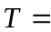
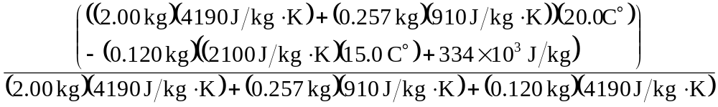
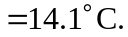 Note that the mass of the ice 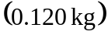 appears in the denominator of this expression multiplied by the heat capacity of water; after the ice melts, the mass of the melted ice must be raised further to 